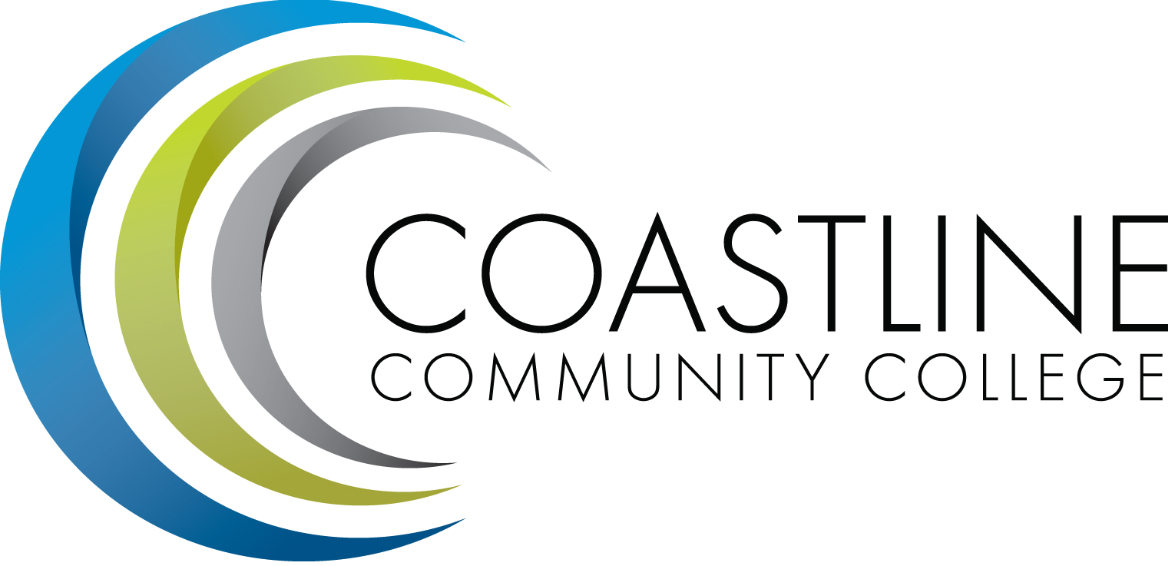
Planning, Institutional Effectiveness, and Accreditation Committee (PIEAC)
October 19, 2016
1:30 p.m. to 3:30 p.m.
Fourth Floor Conference Room

- CALL TO ORDER
  - Roll Call
  - Welcome
  - Adoption of Agenda
  - Approval of Minutes: October 5, 2016

- DISCUSSION & ACTION ITEMS
2.1 Education Master Plan V. Rodriguez
2.2 Categorical Funds for Personnel C. Nguyen
2.3 Key Performance Indicators A. Zentner
2.4 Institutional Effectiveness V. Rodriguez
2.5 Partnering with Front Line Staff L. Adrian
2.6 KPIs for 2016-2020 A. Zentner
2.7 Planning Report 2016-2017 A. Zentner
2.8 EMP 2016-2020 A. Zentner

3. STANDING REPORTS
3.1 Accreditation V. Rodriguez
3.2 Budget Committee R. Lockwood
3.3 Program Review A. Zentner
3.4 Grants D. Aistrich
3.5 President’s Report L. Adrian
3.6 Wing Reports V. Rodriguez, C. Nguyen, R. Miyashiro
3.7 College Council V. Rodriguez
3.8 Facilities C. Nguyen
3.9 Contract Education J. Groot
3.10 Student Success Committee D. Pittaway
3.11 Institutional Effectiveness Grant A. Zentner
3.12 College Promise L. Adrian
3.13 Other Committees Committee

4. ANNOUNCEMENTS (1-2 minutes per)

5. ADJOURNMENT

